# Connection mechanism:

The two batteries should ne connected to their ports as shown in the pictures.

## Ultra sonic connections:

The Ultra Sonic sensors are soldered to the board and connected to the batteries with a wire in the back of the board.

Front sensor trig pin : 5

Front sensor echo pin : 6

Right sensor trig pin : 4

Right sensor echo pin : 3

Left sensor : not defined yet

## Servo connections:

The two left servos are connected to the left pins soldered on the board in order left to right order: PWM (yellow) VCC (RED) GND (BROWN)

And the opposite for the right servos.

## ARDUINO CONNECTION:

The ARDUINO is connected to the pins soldered to the board facing the back of robot.

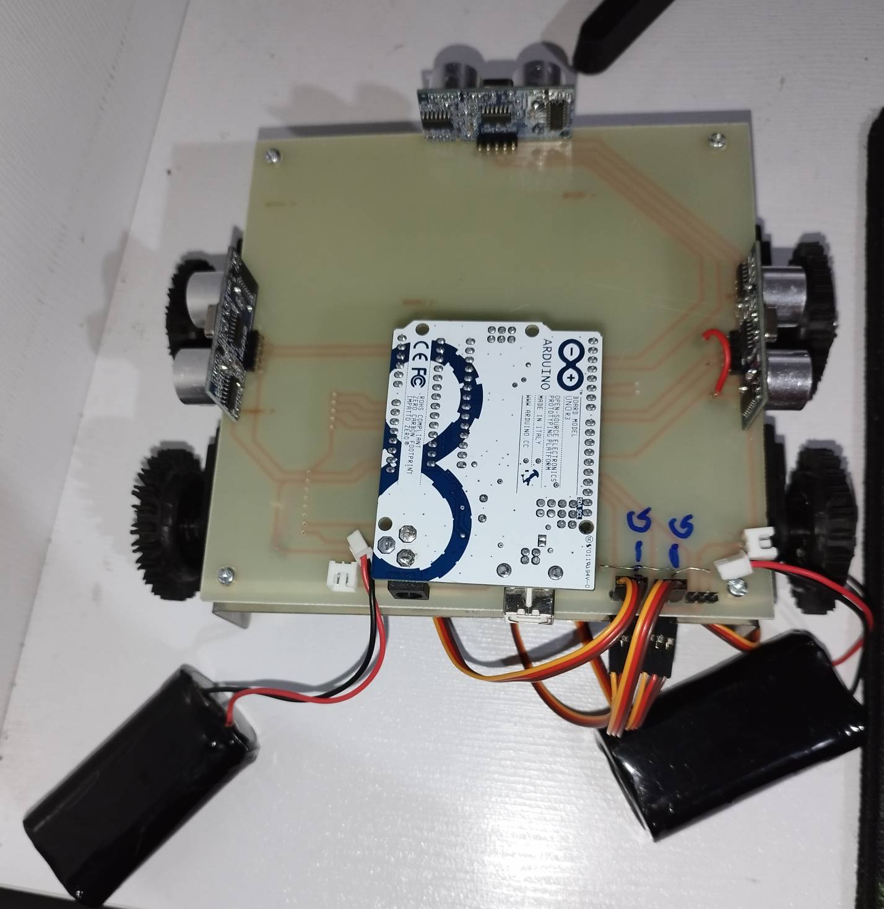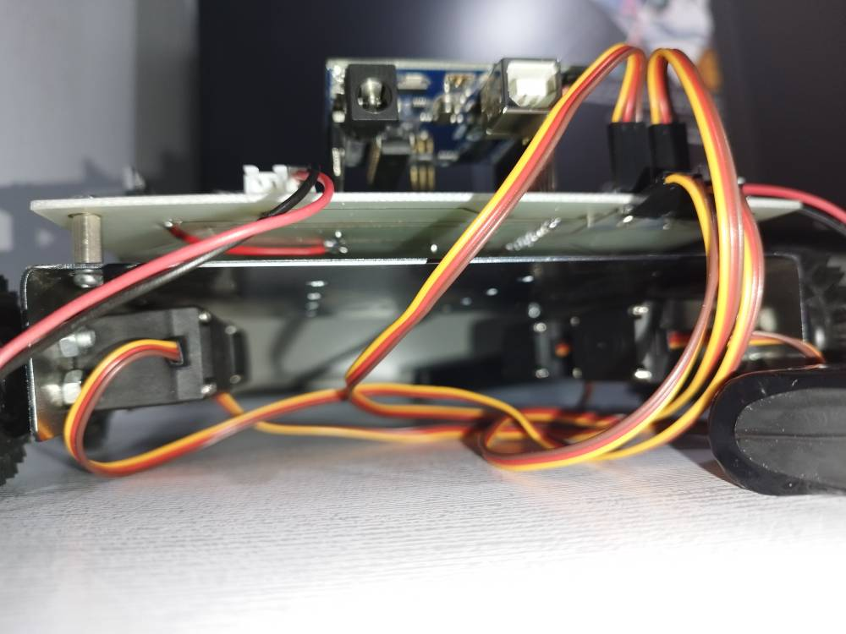

the used source code for the movement of the robot:



USED SOURCES FOR WRITING THIS CODE:

[Programming | Arduino Documentation](https://docs.arduino.cc/programming/)

[Arduino - راهنمای آردوینو](https://arduino.ir/Guide)

[YouTube](https://www.youtube.com/)

source code examples in the Arduino APP

Honorable mention:

chatgpt.com